**Phase 5: Project Documentation & Submission**

In this part you will document your project and prepare it for submission.

Document the website traffic analysis project and prepare it for submission.

**Introduction:**

The "Website Traffic Analysis for Enhanced User Experience" project aims to improve the user experience on a website by leveraging data analysis and visualization. By understanding user behavior and preferences, the project provides actionable insights to help website owners make informed decisions for enhancing their site's usability and content.

**Project Objective:**

The primary objective of this project is to analyze website traffic data and extract valuable insights that can lead to improvements in the user experience. These insights will be instrumental in guiding content creation, user interface design, and overall website enhancements.

**Project Phases:**

**Project Planning:**

Define project scope, objectives, and team roles.

Establish data collection methods and tools.

**Data Collection:**

Collect user data from the website, including demographics, page views, click-through rates, bounce rates, and more.

Ensure compliance with privacy regulations and obtain necessary consents.

**Data Preprocessing:**

Clean and format the collected data to ensure data quality.

Handle missing or erroneous data points.

**Data Analysis:**

Utilize Python for data analysis to extract meaningful insights.

Explore patterns, trends, and anomalies in the data.

**Data Visualization:**

Utilize IBM Cognos for data visualization.

Create interactive charts, graphs, and dashboards to represent key metrics.

**Insight Generation:**

Identify trends and patterns in user behavior.

Correlate data to discover user preferences and pain points.

**Recommendations:**

Provide actionable recommendations for website improvements based on insights.

**Analysis Objectives:**

Understand user demographics, including location, age, and device preferences.

Analyze user behavior, such as the most visited pages and the click-through rates.

Identify high bounce rate pages and potential issues causing them.

Determine the preferred content type (text, images, videos) for different user segments.

Discover the most effective call-to-action elements on the website.

**Data Sources:**

Google Analytics or similar web analytics tools for user data.

External data sources for additional context, if needed.

**Tools Used:**

Python for data analysis and preprocessing.

IBM Cognos for data visualization.

**Insights and Outcomes:**The insights obtained from this analysis can significantly enhance the website's user experience:

**Personalization:** User demographics data can help tailor content and design for specific audience segments, making the website more appealing and relevant to users.

**Content Optimization**: Identifying popular content types and subjects can guide content creators in producing materials that resonate with the audience, increasing engagement.

**User Flow Enhancement:** Analysis of click events and page transitions can lead to improvements in user journeys, reducing friction and increasing the likelihood of conversions.

**Bounce Rate Reduction**: Insights into high bounce rate pages enable targeted improvements, reducing user drop-offs.

**Call-to-Action Improvements:** Understanding the effectiveness of CTAs can lead to better placement and design, increasing user engagement and conversions.

**Continuous Improvement:** The iterative design thinking process ensures ongoing enhancements based on user data, fostering a user-centric culture within the organization.

**Program:**

import numpy as np

import pandas as pd

import pandas_profiling

import warnings

warnings.filterwarnings('ignore')

import datetime

from datetime import date

import seaborn as sns

import matplotlib.pyplot as plt

%matplotlib inline

sns.set_style("whitegrid")

# import chart_studio.plotly as py

import cufflinks as cf

import plotly.express as px

from plotly.offline import download_plotlyjs, init_notebook_mode, plot, iplot

init_notebook_mode(connected=True)

cf.go_offline()

import pandas_profiling

import plotly.graph_objects as go

from sklearn.model_selection import train_test_split, cross_val_score, GridSearchCV

from sklearn.metrics import accuracy_score

from sklearn.svm import SVR

from sklearn.linear_model import LinearRegression

from sklearn.tree import DecisionTreeRegressor

import xgboost as xg

df=pd.read_csv('../input/daily-website-visitors/daily-website-visitors.csv')

df.rename(columns = {'Day.Of.Week':'day_of_week'

,'Page.Loads':'page_loads'

,'Unique.Visits':'unique_visits'

,'First.Time.Visits':'first_visits'

,'Returning.Visits':'returning_visits'}, inplace = True)

df=df.replace(',','',regex=True)

df['page_loads']=df['page_loads'].astype(int)

df['unique_visits']=df['unique_visits'].astype(int)

df['first_visits']=df['first_visits'].astype(int)

df['returning_visits']=df['returning_visits'].astype(int)

df

**Output:**

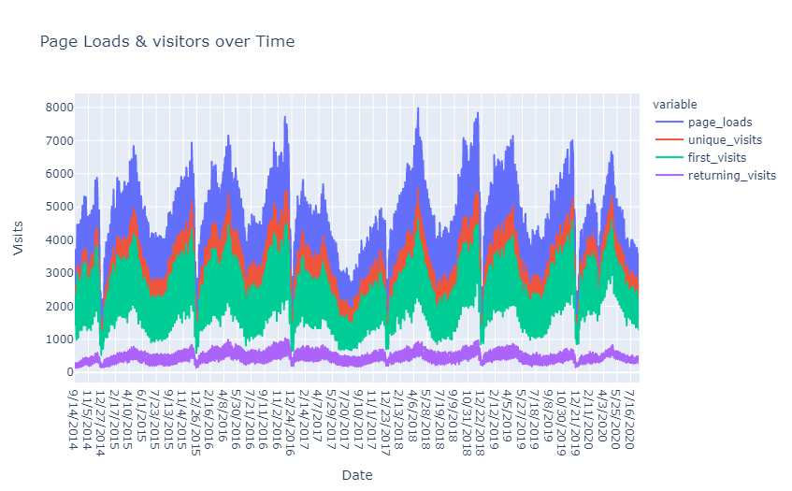

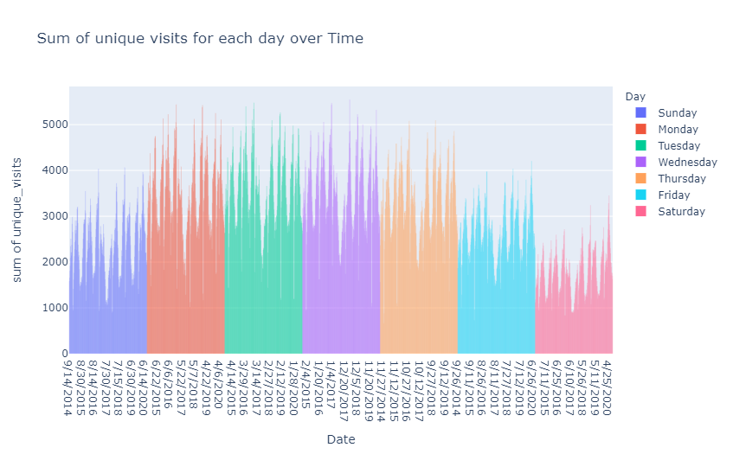

**Conclusion:**

The Website Traffic Analysis project empowers website owners to make data-driven decisions that directly impact the user experience. By continuously monitoring and improving the site based on insights, the website becomes more user-centric, leading to increased user satisfaction, engagement, and potentially higher conversions, ultimately achieving the project's goal of enhancing the user experience.